Name: _____________________________________________________

Teacher: ____________________________________________________

Week 2 Trivia Questions: Pages 60-120
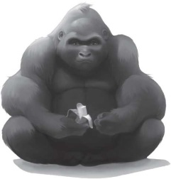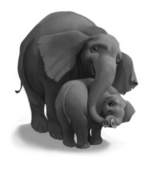

- What is the name of the new baby elephant?

____________________________________________________________________________

2. What two things does Ivan do when Julia suggests he draw the baby elephant?

____________________________________________________________________________

3. What is wrong with Stella’s foot?

____________________________________________________________________________

4. Why are there more cars in the parking lot?

___________________________________________________________________________

5. What does Ivan promise to Stella?

____________________________________________________________________________

6. According to Stella, gorilla hearts are made of….what?

____________________________________________________________________________

BONUS! Go to our One School One Book website at nicholsoneschoolonebook.weebly.com to find out the answer to this question: In what year did Dian Fossey found the Karisoke Research Center in Rwanda’s Virunga mountains to protect and study the near-extinct mountain gorilla?

Answer:_____________________________________________

