Name: _____________________________________________________

Teacher: ____________________________________________________

Week 3 Trivia Questions: Pages 121-179
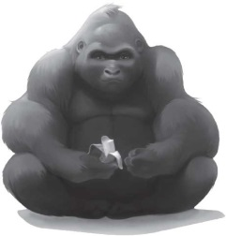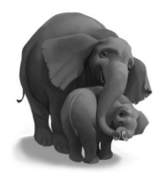

- What did Ivan’s father’s “Grunt” mean?

____________________________________________________________________________

- What did Ivan’s parents call him?

____________________________________________________________________________

- What is a painting a bunch of fruit called?

____________________________________________________________________________

- The finger paints feel like what to Ivan?

___________________________________________________________________________

- Who does the Ivan on the billboard remind him of?

____________________________________________________________________________

- When Ivan is painting his project for Ruby puzzle, his fingers glow like...what?

___________________________________________________________________________

BONUS! Go to our One School One Book website at nicholsoneschoolonebook.weebly.com to find out the answer to this question: What zoo did the real Ivan move to in 1994?

Answer:_____________________________________________

