Name: _____________________________________________________

Teacher: ____________________________________________________

Week 4 Trivia Questions: Pages 180-240
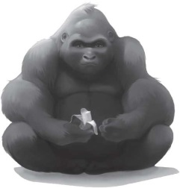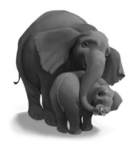

- If Ivan had a badge, he would feel like a...what?

____________________________________________________________________________

- What word does Ivan want to spell?

____________________________________________________________________________

- Why is Ivan angry?

____________________________________________________________________________

- What is Julia’s favorite sign?

___________________________________________________________________________

- What does the lady with the white coat use as rewards when she is training Ruby to get into the new box?

____________________________________________________________________________

BONUS! Go to our One School One Book website at nicholsoneschoolonebook.weebly.com to find out the answer to this question: How many years did THE REAL IVAL spend alone in a cage?

Answer:_____________________________________________

