Name: _____________________________________________________

Teacher: ____________________________________________________

Week 5 Trivia Questions: Pages 241-300
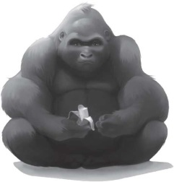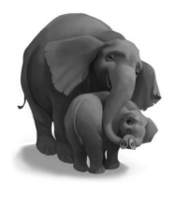

- Maya uses four kinds of food to try to entice Ivan into his box. Can you name at least two?

____________________________________________________________________________

- The first thing Ivan notices about his new cage is...what?

____________________________________________________________________________

- Instead of sticky-fingered children and weary parents, who visits Ivan in his new place?

____________________________________________________________________________

- What does Ivan try to remember about being a gorilla? (Can you recall at least two?)

___________________________________________________________________________

- Julia is walking three...what...to pay for Bob’s food?

____________________________________________________________________________

BONUS! Go to our One School One Book website at nicholsoneschoolonebook.weebly.com to find out the answer to this question: What is a previous One School One Book title?

Answer:_____________________________________________

